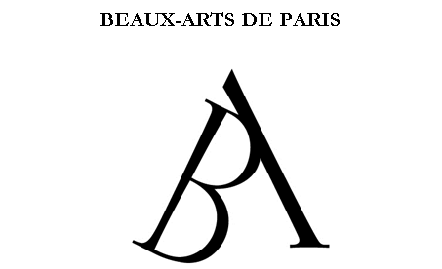

EXCHANGE STUDENT APPLICATION FORM
IMPORTANT

Please attach
photo
2018-2019

GENDER 􀀀 MALE 􀀀 FEMALE
FAMILY NAME: FIRST NAME:
PLACE OF BIRTH: DATE OF BIRTH:
NATIONALITY:
HOME ADDRESS:
COUNTRY:
PHONE NUMBER:
E-MAIL:
PARENTS’ PHONE AND E-MAIL:

HOME SCHOOL:
ACADEMIC ADVISOR (name and contact):
EXCHANGE COORDINATOR (name and contact):
NUMBER OF YEARS OF FINE ARTS STUDY:
MAJOR: 􀀀 PAINTING 􀀀 SCULPTURE 􀀀 MULTIMEDIA
FRENCH PROFICIENCY: 􀀀 FLUENTLY 􀀀 FAIRLY WELL 􀀀 SLIGHTLY
PERIOD OF STUDY AT BEAUX-ARTS:
􀀀 FIRST SEMESTER (FALL) 􀀀 SECOND SEMESTER (SPRING)

NAME OF THE REQUESTED ARTISTIC STUDIO PROFESSOR*:

*please note that studies at BEAUX-ARTS revolve round the notion of the studio, - a space where students execute their practical work under the auspices of an established artist, visiting students are required to join a studio. Requests will be considered but are not guaranteed.

HEALTH INSURANCE:
Name of Insurance Provider:
Policy / Identification Number:

IMPORTANT NOTE: All students are required to be covered by a health insurance policy from a private insurer or a national insurance scheme. Insurance must cover, at a minimum, medical costs, hospitalization, surgery and repatriation, subject only to customary deductibles and co-payment provisions. You must send a copy of an attestation from your insurer (in English or French) confirming your coverage.
Students who do not have adequate coverage will need to subscribe to a policy from a French insurer, covering any items not already covered by the home country policy.
Students who do not provide an attestation of insurance will not receive their student cards.

DATE:

STUDENT’S SIGNATURE:

SENDING INSTITUTION COORDINATOR’S SIGNATURE AND STAMP:

