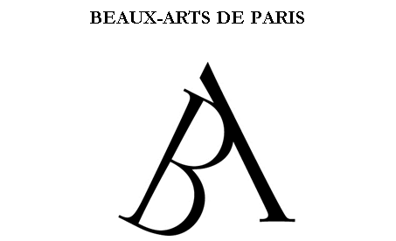
Incoming Exchange - General Information
2019-2020

- DOCUMENTS REQUIRED FOR APPLICATIONS:

- A nomination letter from the home school;
- An art portfolio in paper format;
- A letter of motivation of the applicant which presents a short description of his/her current artistic work, explains why he/she wants to study at Beaux-Arts and specify the studio that he/she wishes to join;
- COMPLETED application form;
- A resume;
- A copy of the passport;
- Two ID photos.

We ask our partners to send applications BY POSTAL MAIL to the following address:
Ecole des Beaux-Arts de Paris, Service des relations internationales,
14 rue Bonaparte – 75272 Paris cedex 06 – FRANCE

- APPLICATION DEADLINES:

Complete applications for the Fall Semester must be received by May 1st, 2019.

Complete applications for the Spring Semester must be received by October 15th, 2019.

EXCHANGE STUDY PROGRAMME:

An English version of our student handbook and a biography of our Professors are available on the website: http://www.beauxartsparis.fr/en/study/international

The Beaux-Arts study programme follows a curriculum based on the standards of the European Credit Transfer System (E.C.T.S.). It does not provide any grades or marks.
Foreign students participate in the common course programme and must take 4 course units (unités de cours, “UC”) in the semester spent at Beaux-Arts for a total of 30 credits:

- Studio UC - Artistic Practice Department: 16 credits
- Technical Skills UC : 6 credits
- Elective UC: 6 credits ; may be chosen from courses in Technical Skills, Drawing Section, Print-making Bookmaking Section, Digital Technologies Section, Theoretical Study Department
- Language UC : 2 credits
During the orientation week, non-French speaking students take a test to determine their level of French. French classes are given for three hours per week and are compulsory for non-French speaking students.
French-speaking students must take a Theoretical Study UC (2 credits). Non-French speaking students may participate in the Theoretical Study UC as an elective course only.

ACADEMIC CALENDAR:

Our Fall term begins usually at the end of September and lasts until mid-January.
Beaux-Arts are closed for two weeks during Christmas period. The assessments are organized in January.

Our Spring term usually begins in mid-January and lasts until mid of May.
Beaux-Arts are closed for one week during Easter period. Full-time students and exchange students can have access to Beaux-Arts during Easter holidays according specific schedules. The assessments are organized in May.

As our artistic practice studios are open in June and July, we usually invite the exchange students to stay at Beaux-Arts after the assessments.

